On the Passing of Edgar Schein

With great sadness we inform you of the passing of Edgar H. Schein on January 26th, 2023.
His son Peter Schein said "Ed passed away suddenly on Thursday evening. He and I had just finished a work gig at about 5p and were chatting after and a few hours after that he passed away peacefully, no pain, no illness, no hospitalization. As he wanted it. Just a bit sudden for us…"
Gervase Bushe wrote: “Ed was a giant who helped to create the field of organization development while a professor at MIT, along with Warren Bennis, Richard Beckhard and Doug McGregor. One of the first books I read when entering the field in the mid 1970's was Bennis & Schein's Personal and Organizational Change Through Group Methods - considered an essential text for anyone training to lead T-groups. He was one of the editors of the Addison-Wesley Series in OD, which helped to define and advance the field, and was the inspiration for the BMI Series in Dialogic OD. Ed was a big supporter of my work on Dialogic OD, seeing it as a return to roots of the field, and while a tough critic, someone whose heart was in it as much as his head.”
Ed and Peter Schein
Ed was also a gentleman, and a gentle man with people he knew and people he didn’t. At conferences and meetings, Ed was always eager to stop and speak with young practitioners, always asking what they were learning. He was a frequent keynoter at the OD Network and featured at the Academy of Management. He was a major presenter at NTL’s 75th Anniversary Jubilee in the summer of 2022. In each case, he was generous with his time and his thoughts. In a recent conversation that he initiated about a series of webinars with founders of the field, Ed was too "Humble" to mention his own name in the conversation, but of course, it is unthinkable to hold an event like that without him.
Ed was enormously prolific. A recent search returned 296 articles, books, and book chapters.
One of Ed’s first articles was “Management Development as a Process of Influence” (1961), One of his first books is still one of his most popular, Career Anchors: Discovering Your Real Values, first published in 1985 and now in its 4th publication. Also in 1985, Ed published the first book in what would become a defining concept for the field of OD, organizational culture beginning with Organizational Culture and Leadership (1985) and the dozens of books and articles related to that.
Ed’s was always curious and exploring the role of the consultant and the psychodynamics of the consulting relationship. His most recent writing has been in the “Humble” series, but its roots are in his earliest writing, Process Consultation: Its Role in Organization Development (1969), which clearly defined the differences between expert and process consulting, a concept that is still foundational to the work of OD consultants everywhere. Those same questions are beautifully and elegantly explored in Humble Inquiry (2014), Humble Consulting (2016) Humble Leadership (2018) and the updated Humble Inquiry: The Gentle Art of Asking Instead of Telling (2021). His last two books were cowritten with his son, Peter.
Ed wrote frequently about his consulting experiences, including DEC Is Dead: Long Live DEC (2003), the lessons American managers can learn from Japanese management (1996), to the culture of Singapore’s Economics Development Board (1996), and his oft-cited story about confessing his ignorance during a process consulting engagement with the New York Times editorial board, which turned up the fact that there was no order or structure of priority to their meeting agenda, which contributed mightily to their dysfunction
Ed’s many awards include the 2000 Lifetime Achievement Award from ASTD, the Hughes Award for Career Scholarship in 2000 from the Academy of Management, 2009 Distinguished Scholar-Practitioner Award from the Academy of Management, the 2012 Lifetime Achievement Award from the International Leadership Association, and two awards from the Organization Development Network: Members’ Choice Award for 2004 Most Influential Books, and the Network’s Lifetime Achievement Award in 2005.
Edgar Henry Schein was born on March 5, 1928 in Zurich and died at the age of 94. He said, “I think it was significant that I was an only child. It was significant that my father was a physicist who, because of various circumstances, had to leave Switzerland, so at age six I went to Russia to learn a new language and a new way of living. Three years after that, we left Russia and I spent a year in Czechoslovakia and learned some Czech. Then in 1938, came to the U.S. and, for the first time, learned some English, and at that point, learned how to be an American.”
There is a remarkable telling of his remarkable life in a fascinating oral history which can be reached at:
https://tobiascenter.iu.edu/research/oral-history/audio-transcripts/schein-edgar.html
He was a Professor of Management Emeritus at MIT Sloan School of Management, and is still listed on their website with an office, office hours, and a phone number. He was a much beloved teacher, leader, author, mentor, and friend to many of all generations in OD and social psychology. We will miss him dearly.
Matt Minahan

Edie Seashore and Ed Schein

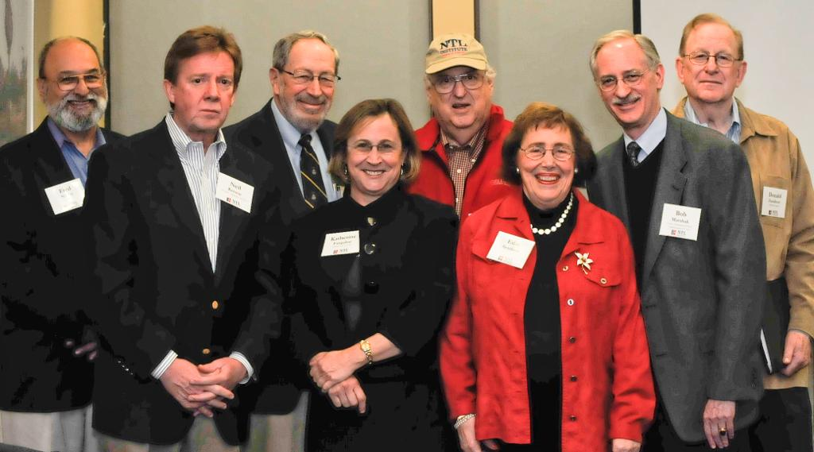
2009 Leaders of the AU/NTL Program
Fred Nader, Former President, NTL
Neil Kirwin, Program Faculty and AU President
Ed Schein
Katherine Farquhar, AU/NTL Program Director
Charlie Seashore, AU/NTL Faculty
Edie Seashore, AU/NTL Co-Founder and Faculty
Bob Marshak, AU Professor Emeritus
Don Zauderer, Former Director, AU/NTL Program

References:
Schein, E. H. (1961). Management development as a process of influence. Industrial Management Review (pre-1986), 2(2), 59.
Schein, E. H. (1981). Does Japanese management style have a message for American managers?. Sloan Management Review (Pre-1986), 23(1), 55.
Schein, E. H. (1985). Career anchors. San Diego: University Associates.
Schein, E. H. (1985). Organizational culture and leadership. San Francisco: Jossey-Bass
Schein, E. H. (1987). The clinical perspective in fieldwork. Sage Publications, Inc.
Schein, E. H. (1996). Strategic Pragmatism: The Culture of Singapore's Economics Development Board. MIT Press.
Schein, E. H. (1996). Organizational learning: What is new?
Schein, E. H. (2014). Humble inquiry. Gildan Audio.
Schein, E. H. (2016). Humble consulting: How to provide real help faster. Berrett-Koehler Publishers.
Schein, E. H., & Schein, P. A. (2018). Humble leadership: The power of relationships, openness, and trust. Berrett-Koehler Publishers.
Schein, E. H., & Schein, P. A. (2021). Humble inquiry: The gentle art of asking instead of telling. Berrett-Koehler Publishers.
https://mitsloan.mit.edu/faculty/directory/edgar-h-schein

